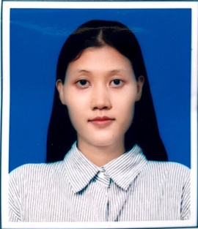

**CURRICULUM VITAE**

**PERSONAL**

NAME : Ma Yu Lae Phyu

AGE : 24

DATE OF BIRTH : 9 September 1998

NRC NO : 8/YASAKA (NAING) 216809

FATHER NAME : U Nwet Aye

RACE : Burma

RELIGION : Buddhist

NATIONALITY : Myanmar

GENDER : Female

HIGHT : 5'4"

MARTIAL STATUS : Single

**EDUCATION**

* Bachelor of Engineering (IT) (Final year) Technological University (Monywa), Waiting for a degree

**WORK EXPERIENCE**

* Internship at Micro Services Myanmar at Yangon for three months ( June 10, 2020- August 10, 2020)

**UNIVERSITY LIFE EXPERIENCES**

* Perform the Project of “Gold Selling and Buying” as a Member (2018)
* Perform the Project Member of “Travelling in Myanmar” (2019)
* Perform the Project of “Food Ordering and Delivering System for Monywa Region” as a Member (2020)
* Perform the Thesis Project “Checkers Game” for a BE(IT) degree

**CERTIFICATES**

* Certificate in “Professional Web Design Course” at CODE LAB

**INTERESTED AND SKILL**

* Interested in learning new programming languages to work as a team
* Willing to work with organizations to get many experiences
* HTML, CSS, JavaScript, My SQL, PHP, Java

**OFFICE TOOLS**

* Microsoft Word(Advance)
* Microsoft Excel(Basic)
* Microsoft PowerPoint(Intermediate)

**CONTACT**

Address : 26th Street, Middle block, Sule

Phone : 09-792908264

Email : yulaephyu1645@gmail.com